**Leader Overview**

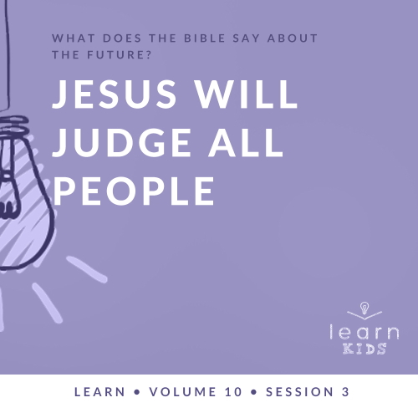

**Volume Overview**

**What does the Bible say about the future?**

*It’s easy to see that our society is obsessed with the future. But what does the Bible say about the future? While it was written thousands of years ago and much of its contents has already taken place, we do get a glimpse of the future in the Bible. We know there is life beyond this life. We know the brokenness and pain in this world will not last forever. We know God will make all things new, and He will right every wrong. For Christians, the future is something we can look forward to.*

**Session Overview**

**Jesus Will Judge All People**

*It’s important for kids to understand that their choices have consequences. God has given us all the freedom to choose. The parable Jesus shared reminds us we must make the right choices in life if we want to spend eternity with Him. Of course, the most important of those choices is to follow Jesus. We only have one life to live and one chance to choose to follow God.*

**Bible Lesson**

Parable of the Rich Man and Lazarus

[Luke 16:19–31](https://ref.ly/logosref/Bible.Lk16.19-31); [2 Corinthians 5:10](https://ref.ly/logosref/Bible.2Co5.10)

**Faith Fact**

Jesus gives me a choice.

**Faith Verse**

[1 Corinthians 2:9](https://ref.ly/logosref/Bible.1Co2.9) (NLT)

“No eye has seen, no ear has heard, and no mind has imagined what God has prepared for those who love him.”

**Preparing for the Session**

**Leader Preparation Time: 20–25 Minutes**

|  |
| --- |
| ***You Will Need***  ***Large Group***   * *Bible* * *Worship songs (Song suggestions: “Revelation Song” by Gateway Worship; “Ready or Not” by Hillsong UNITED; “Alive” by Hillsong Young & Free; “Zeal” Lyric Video by The Belonging Co)* * *For groups not using a phone or tablet only, add:*   *• Projector or TV*  *• Laptop*  *•* ***Faith Fact Slide***  *•* ***Faith Verse Video*** *or* ***Slide***  *•* ***Bible Lesson Video***  *•* ***Large Group Game Over Slide***  *•* ***Teaching Point Slides 1–3***   * *Prizes* * *Video game* * *Controller* * *Sheets of paper, one per kid* * *Pencils, one per kid* * *Trash can*   ***Small Group***   * *Bibles for kids in your group to share* * ***Small Group Faith Verse Review Page****, two sets per group* * *Scissors* * *Prize* * ***Small Group Activity Page****, one per kid* * *Pencils, one per kid* * *Crayons or markers*   *To access session content and videos from a computer, visit:* [*BibleEngagementProject.com/downloads*](https://bibleengagementproject.com/downloads) |
| ***Getting Ready***  ***Large Group***   * *Download videos and slides if needed.* * *Select worship song(s) and have them ready to play.* * *Read the Bible Lesson Scripture to prepare for teaching time.*   ***Small Group***   * *Print and cut apart the* ***Faith Verse Review Page****, two sets per group.* * *Print copies of the* ***Small Group Activity Page****, one per kid.*   *First time leading* Learn *for Kids? Check out the* [*Facilitator Guide*](https://0b769b0ed3569ef9d18b-f88d8272f61086866d50d048b43ef630.ssl.cf2.rackcdn.com/sites/biblengagementproject/Listen_Facilitator_Guide.pdf)*.* |

**Large Group**

**30 Minutes**

*See what’s needed at the beginning of the session.*

**Introduction**

Welcome! We’ve been talking about what the Bible has to say about the future. Some people get nervous when they read what the Bible says about the future. But do Christians need to be afraid of what will happen? *(Group response)* No way! As long as we’ve made the choice to follow Jesus, we have no reason to fear the future.

We all make hundreds of choices each day. What’s the first choice you make when you wake up in the morning? *(Allow responses.)* What about the last choice you make before you go to bed? *(Allow responses.)* We make small choices every day—like what to have for breakfast or what shoes to wear—but we also make big, important choices.

**Faith Fact**

Our Faith Fact tells us who gives us the most important choice we’ll ever make—it’s Jesus! The Faith Fact today is **Jesus gives me a choice.**

• *Show the* ***Faith Fact Slide.***



Let’s say that together. **Jesus gives me a choice.** Say that with me one more time, but this time, pretend you’re opening the greatest gift ever. **Jesus gives me a choice.** Jesus lets us choose to follow Him or not. Today we’ll find out why that is the most important choice of all.

**Game**

**The Judge Rules**

|  |
| --- |
| ***You Will Need***   * *Prizes*   *No prep needed for this activity.* |

Jesus is the final Judge for our life. That’s why we must choose to follow Him. But just for fun in today’s game, some of you will get to be the judge. The judge will rule for one round and choose the winner. Then somebody else will get a turn to be the judge.

• *Choose a volunteer to be judge for Round One.*

Each of you can choose if you want to compete in a round. I’ll announce the category, and if you want to compete, come up to the front so the judge can see you. Then the judge will choose the winner. Here are the categories:

1. Highest jump

2. Coolest accessory (something extra you’re wearing—like a belt or necklace)

3. Funniest facial expression

4. Most impressive physical trick (something not everyone can do)

5. Best athletic move

You can compete in as many rounds as you want. That’s your choice. Let’s play!

• *After each round, give the winner a prize and choose a new judge.*

It can be fun to be a judge with the power to make decisions. Can you remember who the ultimate Judge is? *(Group response)* That’s right! Today, we’ll talk more about how Jesus is the ultimate Judge. He’s the only One who can judge us in a way that really counts for eternity.

**Worship**

Let’s worship Jesus today and thank Him for giving us choices. I encourage you to choose to worship Him with all you have today! One way to worship Jesus is by singing. Let’s worship Him by singing now.

• *Lead the kids in singing one or two praise songs. See suggestions at the beginning of the session.*

**Bible Lesson**

Thanks for worshipping with me! Are you ready to hear another amazing parable from the Bible? *(Group response)* Who can remember what a *parable* is? *(Allow responses.)* It’s a story with a point that’s easy to remember. Jesus used parables to help people understand what He taught and then use it in their own life. Today’s parable is sadder than most of the ones Jesus told. But it’s very important. It shows us how life-changing our choices can be. Let’s pray and ask Jesus to get us ready to receive His message.

**Prayer**

|  |
| --- |
| *Dear Jesus, thank You for giving us a choice. Please help us make the right choice. Help us to choose to follow You. Amen.* |

**Video Intro**

Before we look at the Bible story, let’s check out this video.

• *Play* ***Bible Lesson Video.***



**Bible Story**

**Parable of the Rich Man and Lazarus**

That video helped to get us ready for our Bible story today. This parable Jesus told was about two men: a poor man named Lazarus and a rich man whose name we don’t know. Would you rather be rich or poor? *(Group response)* Most of us would want to be rich, but the rich man in Jesus’ story didn’t have a happy ending. The problem wasn’t that he had a lot of money, but that he made bad choices. The way he chose to live caused him to end up in trouble. It’s time to open your Bible or Bible app and go to [Luke 16:19–31](https://ref.ly/logosref/Bible.Lk16.19-31).

• *Read the passage aloud to the group.*

• *In order to keep Large Group time moving along, we don’t recommend having the kids read.*

• *Optional: Remind the kids to mark this place with their Bible Bookmark, so they can read it on their own at home.*

**Teaching Time**

|  |
| --- |
| ***You Will Need***   * *Video game* * *Controller* * ***Large Group Game Over Slide***   *No prep needed for this activity.* |

Jesus’ parable reminds us of something that’s sad, but true: If we make the bad choice of not following Jesus, we’ll spend eternity without Him. The rich man lived a comfortable life on earth. He had everything he wanted, but he didn’t have the one thing he really needed. He didn’t choose to live for Jesus. Lazarus was poor and his life on earth was difficult, but he got to spend forever with Jesus. Now that you know the end of the story, would you rather be like the rich man or the poor man? *(Group response)*

Forever lasts so much longer than our life here on earth. It’s hard to even imagine how long forever will last! That’s why our Faith Fact is so important. Say it with me. **Jesus gives me a choice.** Jesus lets us decide whether we follow Him or go our own way. He wants us to make the right choice and give our life to Him. But He won’t make us follow Him. Let’s look at a few things we can learn from this parable.

**1. We all get to choose how we want to live.**

• *Show the* ***Teaching Point 1 Slide.***

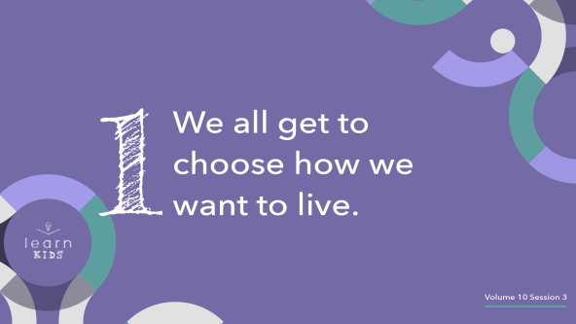

Jesus can do anything. He is all-powerful. If He wanted to control us, we could have been created to be like robots. He could have made all our choices for us. But Jesus gives us free will. He doesn’t force us to love Him. We all choose between following Jesus or walking away from Him.

People make hundreds of choices every day. Our life is kind of like a video game. (*Hold up a video game.)* Who loves playing video games? *(Group response)* What’s your favorite game? Shout it out on the count of three. One, two, three! *(Group response)* Video games are full of choices. You might choose what your character wears, how it looks, or even what skills you have.

Your decisions make the game fun and let you feel in control. After all, it wouldn’t be much fun to play a video game where everything was decided for you. That would be like watching a demo or a video instead, and most people wouldn’t want to play.

The same is true about life. Think about it: Life wouldn’t be as interesting if we couldn’t make choices. And the most important choice is whether we’ll follow Jesus and honor Him in everything we do.

**2. Our choices in life determine what happens after death.**

• *Show the* ***Teaching Point 2 Slide.***

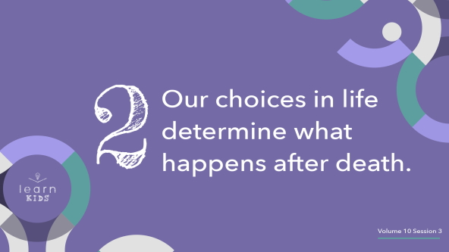

The things we decide make a huge difference. Jesus has given us so much responsibility! The rich man in the parable didn’t act like his choices in life mattered that much. Maybe he didn’t believe his bad choices would lead to being punished forever after he died. But when it was too late, he begged that Lazarus could go and warn his brothers about what was coming. He wanted them to make good choices, not bad ones like he had.

If we choose not to follow Jesus or believe He is the only way to heaven when we die, then we’re choosing not to be with Him forever—just like this rich man. That’s a choice we can’t change after we die. So we need to make sure we choose to follow Jesus now. It’s the most important choice we will ever, ever make.

Our choices make all the difference. (*Hold up the controller and pretend you’re playing a game.)* It’s like playing your favorite video game. Your choices are the reason you either level up or it’s game over. In a few days or weeks, the decisions you made in a video game won’t matter that much. But your real-life choices matter forever. It makes a difference how you choose to spend your time. It makes a difference who you choose as friends. And most important of all, it makes a difference whether you say yes or no to following Jesus.

**3. Jesus’ judgment after death is final.**

• *Show the* ***Teaching Point 3 Slide.***

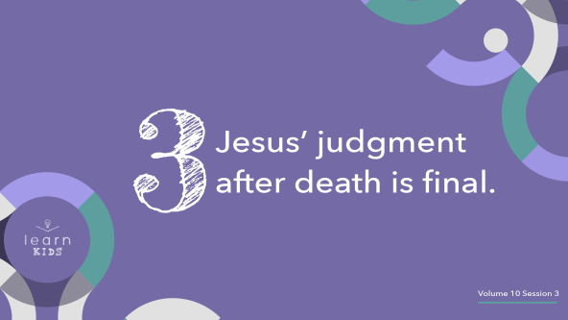

Let’s never allow our friends or anyone else to guide us toward bad choices. The truth is, each one of us will be judged by Jesus. I will stand before Him by myself someday, and so will you. When life is over, it will be too late to repent and decide to follow Jesus. If we decided not to follow Jesus during our life, we’ll spend forever without Him, just like the rich man.

This parable shows us no one can change their choices after they die. By then, it’s too late. When our life is over, it’s not like the end of a video game.

• *Show the* ***Large Group Game Over Slide****.*



Jesus’ judgment is final, and there aren’t any do-overs. You can’t just reload your life and play again. Your choices can’t be changed. But this doesn’t have to be bad news! Remember, **Jesus gives me a choice**. You can choose to follow Jesus *right now*. And you can keep making good choices that lead to spending forever with Him.

**Prayer and Response**

*Consider playing a worship song softly in the background while kids pray.*

|  |
| --- |
| ***You Will Need***   * *Sheets of paper, one per kid* * *Pencils, one per kid* * *Trash can*   *No prep needed for this activity.* |

We only have one life to live, and Jesus gives us a choice. Will you choose to follow Him? That’s the most important choice anyone can make. If you want to start following Jesus, or if you want Jesus’ help to stay faithful until He comes back, I want to pray with you!

• *Take time to pray with kids.*

After we make that life-changing choice to follow Jesus, we should keep making good choices. That’s how we keep following Jesus the rest of our life. That’s how we stay ready to stand before Him someday.

Maybe you’ve been making some choices that you know aren’t the best. Maybe you chose to lie to your friend. Maybe you chose to disobey your parent or teacher. Maybe you chose to cheat on a test. How can you tell that a choice is wrong? One way is to think about whether you’d want Jesus to know about it. Would you want Jesus to sit beside you while you’re doing something? If not, it’s a bad choice.

We’re going to ask Jesus to show us our bad choices and help us stop making them. When you get your piece of paper, write down or draw what Jesus shows you.

• *Pass out the sheets of paper and pencils to the kids and encourage them to write down some of the bad choices they have been making.*

• *Write down your bad choice(s) and participate in the following response.*

To show how much we want to stop making bad choices, let’s wad up our papers and throw them in the trash. Then we’ll ask Jesus to help us make good choices.

• *Invite kids to come to the front and discard their paper in the trash can.*

**Prayer**

• *Optional: Have the kids repeat phrases of the prayer after you.*

|  |
| --- |
| Dear Jesus, please forgive me for making bad choices and doing things that go against Your plan. Help me to stop making bad choices and start making good choices. Help me to follow You faithfully, so I can live with You forever. Amen. |

**Faith Verse**

Our Faith Verse reminds us that Jesus’ way is the best way. He gives us a choice, but we should always ask what He wants us to do. Let’s say our Faith Verse and do the actions together.

• *Play* ***Faith Verse Video.***

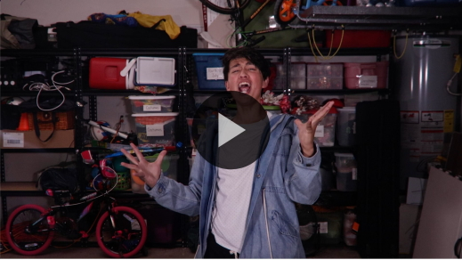

[1 Corinthians 2:9](https://ref.ly/logosref/Bible.1Co2.9) (NLT)

“No eye has seen, no ear has heard, and no mind has imagined what God has prepared for those who love him.”

When I die, I don’t want to be like the rich man in the parable. I want to be part of all God has prepared for me—like this verse says! What about you? *(Group response)*

**Faith Fact**

Before we go to our small groups, let’s say our Faith Fact again.

• *Show the* ***Faith Fact Slide****.*



This time, let’s point up when we say “Jesus” and point at ourself when we say “me.” **Jesus gives me a choice.** One more time. **Jesus gives me a choice.** Let’s commit to following Jesus and making good choices today and every day.

• *Dismiss kids to Small Group time or to go home if your group time ends here.*

**Small Group**

**30 Minutes**

*This section can be done in conjunction with the large group, or on its own if you do small groups with your kids. During Small Group time, the goal is to connect the kids with the Word of God and each other. All activities are led by the small group leader.*

**Group Connection**

**What’s Your Choice?**

|  |
| --- |
| *No prep needed for this activity.* |

We’ve been talking about important choices, and I pray every one of you chooses to believe in Jesus and follow Him. But not every choice in life is that important. We make hundreds of choices every day, and some are so small we don’t even think about them.

We were created to be able to make choices, so let’s practice making a bunch of them! Are you ready? *(Group response)*

• *Optional: Designate two spots across the room, and let kids run to the spot that represents their choice.*

I’ll read two choices for each round, and you’ll decide which one you like the best. Stand and hold up one finger if you would choose the first thing I say. Stay seated and hold up two fingers to choose the second option.

• *Ask questions that invite kids to share more about their choices. For example: What kind of cookie or ice cream is your favorite?*

Here are the choices:

• Cookies or ice cream?

• TV or movies?

• Internet or video games?

• Cats or dogs?

• Water park or amusement park?

• Wearing shoes or going barefoot?

• Candy or cake?

• Singing or dancing?

• Park or pool?

• Football or basketball?

• Mini golf or bowling?

• Winter or summer?

It was so fun hearing about your choices! Can you think of any other choices we should discuss?

• *Give kids an opportunity to suggest choices.*

These are the kinds of choices we can disagree about, and that’s okay. What’s important is that we all choose to follow Jesus.

**Learn about It**

|  |
| --- |
| ***You Will Need***   * *Bibles for kids in your group to share*   *No prep needed for this activity.* |

**Scripture Search:** [John 5:24–30](https://ref.ly/logosref/Bible.Jn5.24-30); [Acts 17:30–31](https://ref.ly/logosref/Bible.Ac17.30-31); [Revelation 20:11–15](https://ref.ly/logosref/Bible.Re20.11-15)

Let’s learn more about what God’s Word has to say about the future. What does this Scripture mean for our life today and in the future?

• *Give each kid a Bible and search for one or more of the Scriptures as a group together (as time allows). When everyone has found the Scripture, have one of the kids read it. Then answer the question about it: What does this Scripture mean for our life today and the future?*

• *Pair kids who need additional help with older kids or start simple and look up the session’s Bible story Scripture:* [*Luke 16:19–31*](https://ref.ly/logosref/Bible.Lk16.19-31)*. Kids will get better at finding Scriptures the more they practice.*

• *Optional: Make this a competition to see who can find the Scripture first.*

**Bible Reading Tip**

The Bible is full of people who made good and bad choices. The next time you’re reading your Bible, see if you can find any examples. Often, you’ll be able to see the results of people’s choices, too. God included these stories in His Word so we could learn from them and apply them to our own life.

**Challenge**

I challenge you to find one person in the Bible who made a good choice and one person who made a bad choice. Write down the choices they made and the results of their choices. Compare the good with the bad, and write down something you learned. Ask your parent or another trusted adult if you need help.

**Faith Fact**

Who remembers today’s Faith Fact? *(Allow responses.)* Let’s say it together one more time. **Jesus gives me a choice.**

**Group Discussion**

*Feel free to use all or just a few questions as a jumping-off place for good discussion. Questions marked with * are designed for more conversation. Adjust the questions based on the age or maturity of your group. Typically, older kids will be able to dive a little deeper than younger ones.*

**Questions**

• *If small group activities are not immediately following large group time, you may want to read the Bible story passage before this discussion.*

What was the name of the poor man in Jesus’ parable who was begging at the rich man’s gate?

Whose help did the rich man beg for after he died?

What are some easy choices you make every day?

* What are some hard choices you have to make?

* How do you know the difference between a good choice and a bad choice?

What or who helps you make good choices?

* What or who might lead you to make bad choices? How can you keep this from happening?

What is the best and most important choice you should make?

Why does it matter so much whether you choose to follow Jesus?

**Prayer Requests**

*Finish group discussion by sharing prayer requests and praise reports. Keep track of your small group’s prayer requests and review them each time you meet.*

**Prayer**

*Have kids pray for each other’s prayer requests.*

**Faith Verse Review**

|  |
| --- |
| ***You Will Need***   * ***Small Group Faith Verse Review Page****, two per group* * *Scissors* * *Prize*   ***Getting Ready***   * *Print and cut apart the* ***Small Group Faith Verse Review Page****, two sets per group.* |

Our Faith Verse is [1 Corinthians 2:9](https://ref.ly/logosref/Bible.1Co2.9). It promises that God is preparing some incredible things for those who choose to love and follow Him.

• *Show* ***Faith Verse Video.***



[1 Corinthians 2:9](https://ref.ly/logosref/Bible.1Co2.9) (NLT)

“No eye has seen, no ear has heard, and no mind has imagined what God has prepared for those who love him.”

Can anyone tell me the Faith Verse from memory? *(Allow responses.)* Let’s say it together.

• *Lead the kids in saying the Faith Verse again.*

**Faith Verse Fun**

**Verse Matchup!**

Do you have a good memory? *(Group response)* Let’s play Verse Matchup and see just how good your memory is. Each of you will try to match a phrase from the Faith Verse with its identical copy. The person with the most matches will win a prize. When all the cards have been matched, we’ll put the Faith Verse in order.

• *Lay out the Faith Verse cards facedown, mix them up, and make sure they are not overlapping each other.*

• *Have the kids take turns flipping over only two cards each. If they make a match, they get to keep the cards. If they don’t make a match, they turn the cards back over.*

• *Keep playing until all the matches have been found. Have the kids count their matches. The kid with the most matches wins a prize.*

• *Challenge the kids to put the cards in the correct order as a group.*

That was a fun test of our memory! And God’s Word is the most important thing we could ever remember. The verses we memorize will stick with us and come back to our memory when we need them the most.

**Activity Page**

**Bad Choice, Good Choice**

|  |
| --- |
| ***You Will Need***   * ***Small Group Activity Page****, one per kid* * *Pencils, one per kid* * *Crayons or markers*   ***Getting Ready***   * *Print copies of the* ***Small Group Activity Page****, one per kid.* |

If you could hang out with a famous Bible character, who would you choose? *(Allow responses.)* Lots of great people in the Bible made bad choices once in a while. God forgave them when they chose to turn their life around and make good choices again.

• *Hand out a copy of the* ***Small Group Activity Page,*** *a pencil, and crayons to each kid.*

We need to turn from bad choices and make good choices, too. What are the bad choices the kids on the Activity Page are making? *(Allow responses.)* On the right side of your page, draw or write about the good choice they should make if they are following Jesus.

**Dismissal**

Over the next few days, I hope we all think more about the choices we make. Let’s pray and ask Jesus to help us make good choices.

**Prayer**

|  |
| --- |
| *Dear Jesus, thanks for giving us the ability to make choices. Help us to make good choices and follow You in everything we do. Amen.* |

**Faith Fact Recap**

• *Show the* ***Faith Fact Slide.***



Our Faith Fact reminds us that our ability to make choices is a gift from Jesus. Let’s say it one more time together. **Jesus gives me a choice.** I’ll see you next time as we find out more about what God’s Word says about the future.

• *Send home the* ***Small Group Activity Page.***

• *Remind parents that there are* ***Family Devotions*** *available on the app to do with their kid.*

• *Tell everyone the date and time for the next session.*